READ ME

2DES data on Fucoxanthin-Chlorophyll-Protein from Cyclotella meneghiniana
Room temperature
The sample has been prepared by diluting 45 μL of FCPa with a concentration of 575 μg/mL, in a buffer composed of 25 mM of Tris (pH 7.5), 2 mM of KCl and 0.03% of β-DM.

Matalab data

N=Non-Rephasing
R=Rephasing
T=Total

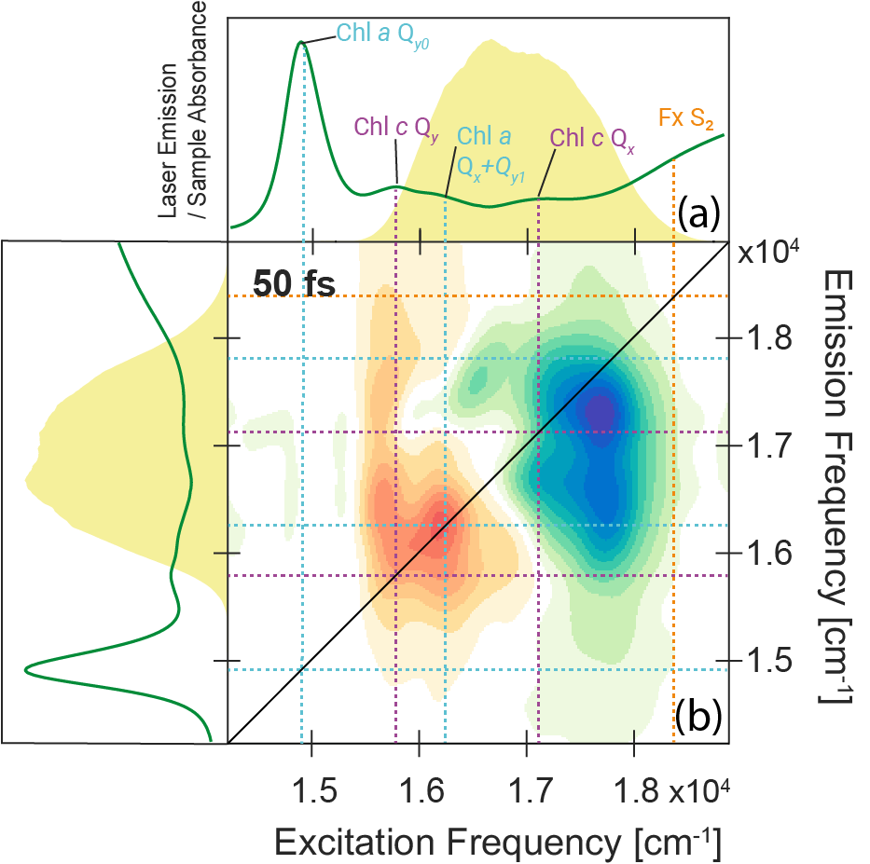
Figure 1. (a) Steady state absorption spectrum of FCP (green line), together with the laser emission profile used for 2DES experiments (yellow area). The main peaks of the spectrum are labelled with the associated attributions in light blue for Chl a, purple for Chl c and orange for Fx. (b) Purely absorptive 2DES map at t₂ = 50 fs. The positive red signals are attributed to the GSB and SE of the chlorophylls and the negative blue signal is related to the ESA signal originating from the S₁ and ICT state of Fucoxanthin.
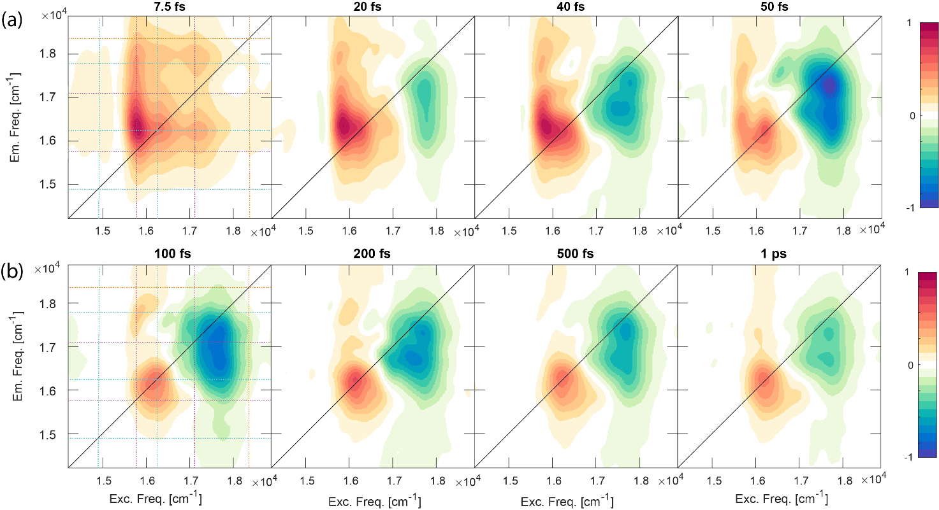
Figure 2. Purely absorptive 2DES maps of FCP at selected values of population time t₂; the maps in panel a (t₂ ≤ 50fs) are normalized on their maximum absolute value, in order to highlight the shape variations of the signals at early times. Maps in panel b (t₂ > 50fs) are normalized on the absolute maximum of the map at 50 fs so that the decay of the signals at increasing time can be better appreciated. The colored dotted lines in the left maps pinpoint the spectral position of the main bands, as attributed in Figure 1.

