Clinical Outcomes of 1625 Subtyped Primary Aldosteronism Patients of the
AVIS-2 Study
SUPPLEMENTAL MATERIAL
Gian Paolo Rossi¹; Giacomo Rossitto^{1,21}; Laurence Amar²; Michel Azizi²; Anna Riester³; Martin Reincke³; Christoph Degenhart³; Jiri Widimsky Jr.⁴; Mitsuhide Naruse⁵; Jaap Deinum ; Leo Schultzekool⁶; Tomaz Kocjan⁷, Aurelio Negro⁸; Ermanno Rossi⁸; Gregory Kline⁹; Akiyo Tanabe¹⁰; Fumitoshi Satoh¹¹; Lars Christian Rump¹²; Oliver Vonend¹²; Holger S. Willenber¹³; Peter Fuller¹⁴; Jun Yang ¹⁴; Nicholas Yong Nian Chee¹⁴; Steven B. Magill¹⁵; Zulfiya Shafigullina¹⁶; Marcus Quinkler¹⁷; Anna Oliveras¹⁸; Kwan Dun Wu¹⁹; Vin Cent Wu¹⁹; Zusana Somloova⁴ ; Giulio Barbiero²⁰; Michele Battistel²⁰; Chin-Chen Chang¹⁹; Paul-Emmanuele Vanderriele¹, Achille C. Pessina¹.

¹University of Padova, Department of Medicine-DIMED, Hypertension Unit, University Hospital, Padova, Italy;
² AP-HP, Hôpital Européen Georges Pompidou, Hypertension Unit, F-75015 Paris, France, Paris-Descartes University, Faculty of Medicine, F-75006 Paris, France, INSERM, UMR970, Paris-Cardiovascular Research Center, F-75015, Paris, France;
³Medizinische Klinik und Poliklinik IV, Klinikum der Universität München, LMU München, München;
⁴Charles University Prague, General Hospital, 3rd Dept. of Medicine, Prague, Czech Republic;
⁵National Hospital Organization Kyoto Medical Center, Dept. of Endocrinology Clinical Research Institute, Kyoto, Japan;
⁶Radboud University Nijmegen, Dept. of Int. Medicine, Nijmegen, Netherlands;
⁷University Medical Centre Ljubljana
⁸Azienda Unità Sanitaria Locale, IRCCS Arcispedale S. Maria Nuova, Dept. of Internal Medicine, Hypertension Unit, Reggio Emilia, Italy;
⁹University of Calgary, Foothills Medical Centre, Calgary, Canada;
¹⁰Institute of Clinical Endocrinology, Tokyo Women's Medical University, Tokyo, Japan;
¹¹Tohoku University Hospital, Dept. of Nephrology, Endocrinology and Vascular Medicine, Sendai,
¹² Heinrich Heine University Düsseldorf , Nephrologie, Duesseldorf, Germany;
¹³ Division of Endocrinology and Metabolism, Rostock University Medical Center, Rostock, Germany;
¹⁴ Monash Health, Clayton, VIC 3168 Australia;
¹⁵ Medical College of Wisconsin. Endocrinology Center. North Hills Health Center, Menomonee Falls, WI 53051.;
¹⁶ Dept. of Endocrinology University of St. Petersburg, Russia;
¹⁷ Clinical Endocrinology, Charité Campus Mitte, Charité University Berlin, Berlin, Germany;
¹⁸ Hypertension Unit, Nephrology Dept. Hosp. del Mar Universitat Autònoma de Barcelona, Spain;
¹⁹ National Taiwan University Hospital, Dept. of Internal Medicine, Taipei, Taiwan;
²⁰ University of Padova, Institute of Radiology, Padova, Italy;
²¹ University of Glasgow, Institute of Cardiovascular and Medical Sciences, Glasgow, UK;

Expanded methods: pages 2-6
Supplemental tables: 4; pages 6-9
Supplemental figure: 4; pages 10-11
EXPANDED METHODS
Center selection criteria
Eligible centers were identified from those that had published in English on PA and/or AVS in the last decade following the PICO strategy (P, population = adults with PA; I, intervention = AVS; C, comparator = simultaneous AVS vs. sequential catheterization technique, use of cosyntropin testing vs. unstimulated condition, use of bilaterally vs. unilaterally selective AVS results, use of absolute hormonal data vs. selectivity and lateralization indices; and O, outcome = the ways AVS was performed and interpreted, adrenal vein rupture) (24). Suitable studies were identified by computer-assisted database searches (PubMed database, U.S. National Library of Medicine) using the key words aldosterone, primary aldosteronism (PA), endocrine hypertension, adrenal vein sampling, and the Boolean operator “AND”; scanning of reference lists; hand-searching of relevant journals; correspondence with authors of relevant reports and meeting presentations; and consultation with experts in the field.
All procedures were carried out according to the Helsinki Declaration. The protocol of the study was approved by the Ethics Committee of both the coordinating center and the participating centers.

Supplemental Table 1: Definitions of the AVS indexes
_______________________________________________________________________________________

Index | Formula | Significance
Selectivity Index (SI) | $$\frac{{PCC}_{adrenal vein}}{{PCC}_{IVC}}$$ | SI estimates the correct positioning of catheters in the adrenal vein
Lateralisation Index (SI) | $$\frac{{{PAC}_{dominant side}}/{{PCC}_{dominant side}}}{{{PAC}_{non-dominant side}}/{{PCC}_{non-dominant side}}}$$ | LI measures the aldosterone secretion of the dominant over the contralateral adrenal gland corrected for the degree of selectivity and for blood dilution from extra-adrenal sources.

PAC = plasma aldosterone concentration. PCC = plasma cortisol concentration. IVC = inferior vena cava. Dominant side = the side with higher RASI value.
________________________________________________________________________
Data handling and statistical analysis
After database locking, data were checked for internal consistency and queries were clarified with each centre’s lead investigator. Data were then harmonized to a standard format before undertaking the statistical analysis as described (in the Supplemental Material).
For centers where only direct (active) renin concentration (DRC) values were measured, plasma renin activity (PRA, in ng/ml/h) was calculated by dividing DRC values (mIU/L) by 8·2, according to the Endocrine Society guidelines.¹⁶
For centers where only direct (active) renin concentration (DRC) values were measured, plasma renin activity (PRA, in ng/ml/h) was calculated by dividing DRC values (mIU/L) by 8·2, according to the Endocrine Society guidelines.¹⁶
Results are expressed as mean ± SD, or median and interquartile range (IQR), as appropriate. Continuous variables were tested for normal distribution with Kolmogorov-Smirnov test and log-transformed data if they showed a skewed distribution before statistical comparisons with parametric tests. Nonparametric tests (Wilcoxon) were used if necessary. Pearson’s χ² test was used to analyse deviation of categorical variables from the null hypothesis of an even distribution across cells. SPSS for Mac (vers. 25 for Mac, IBM-SPSS Bologna, Italy), and GraphPad, Prism (vers. 8·02 for Mac, GraphPad Software, La Jolla California USA) softwares were used for the analysis. Significance was set at p<0·05.

Data collection form for AVIS2 (1)

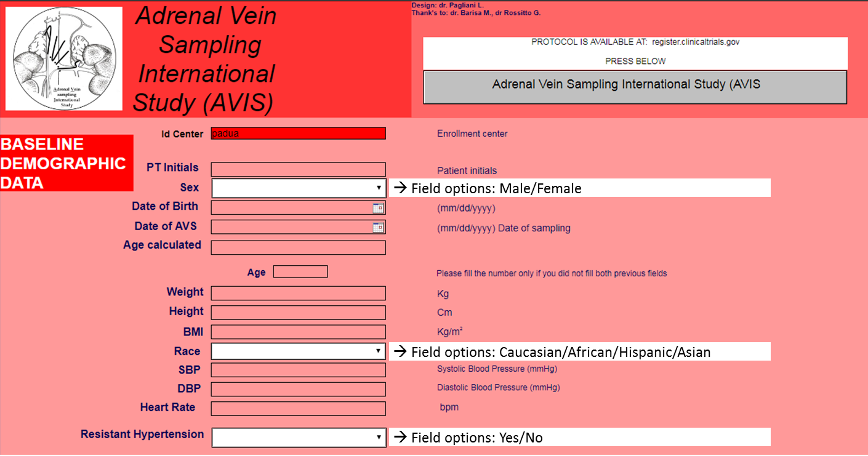
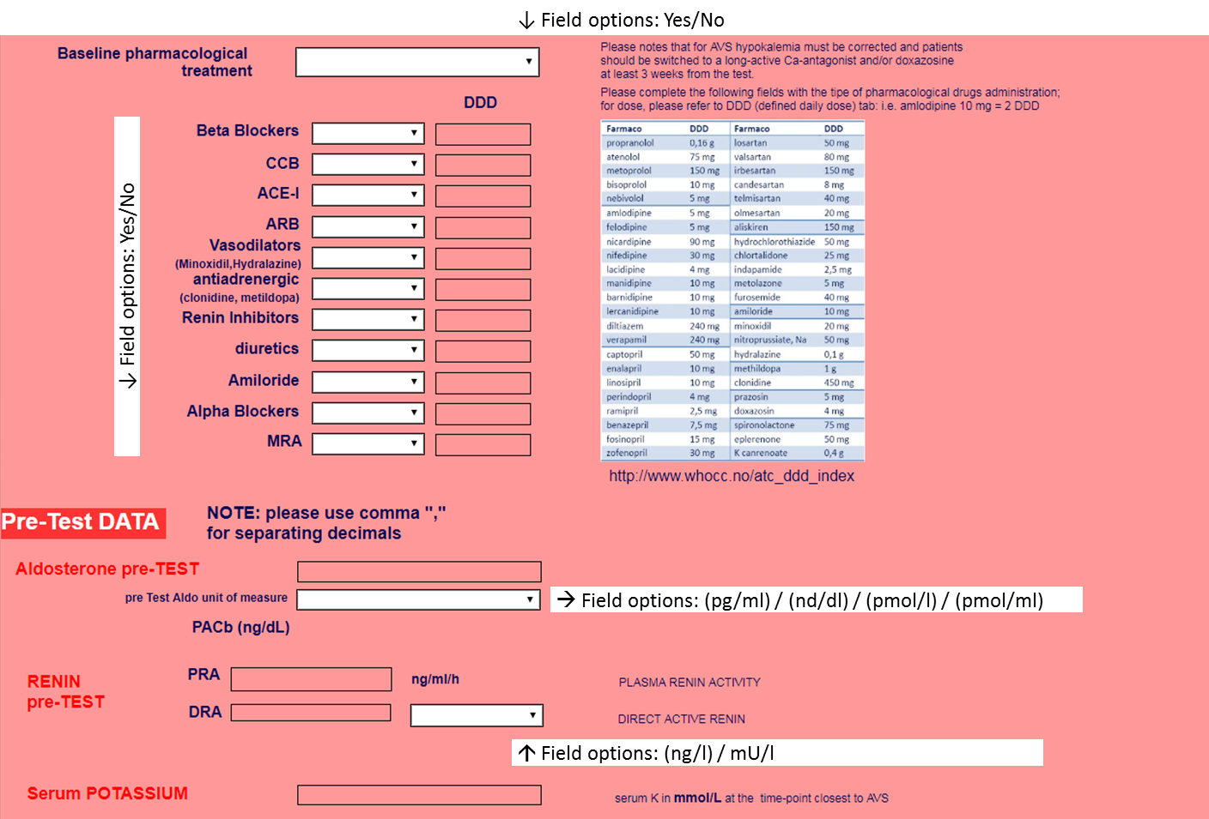
*
* DDD was not prespecified at the beginning of the study; was later introduced but excluded from the current analysis because not available from all centers and/or all patients
Data collection form for AVIS2 (2)

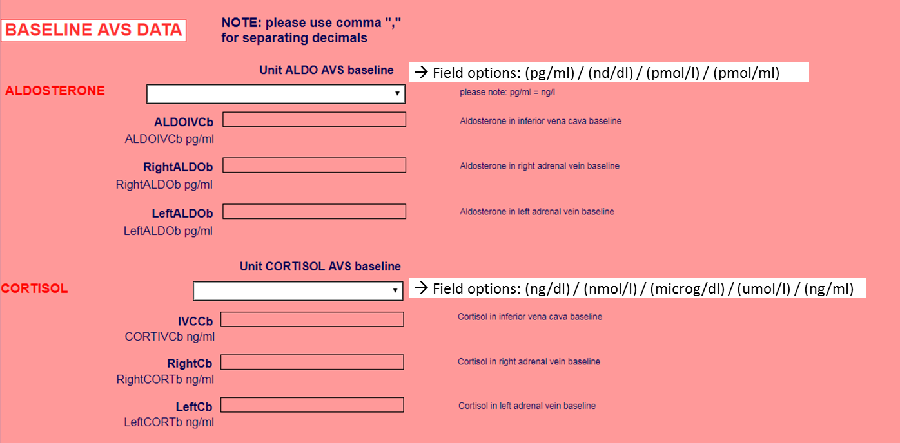

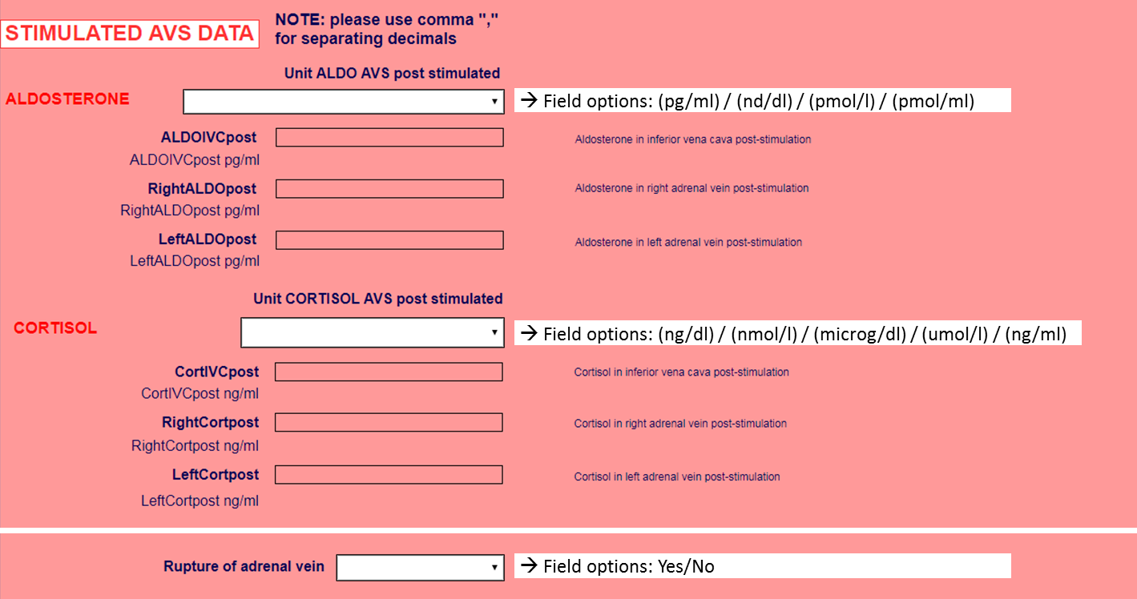

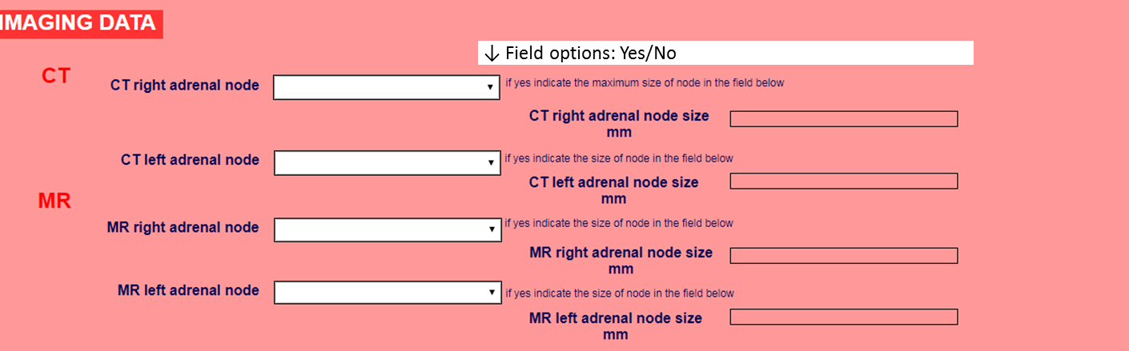

Data collection form for AVIS2 (3)

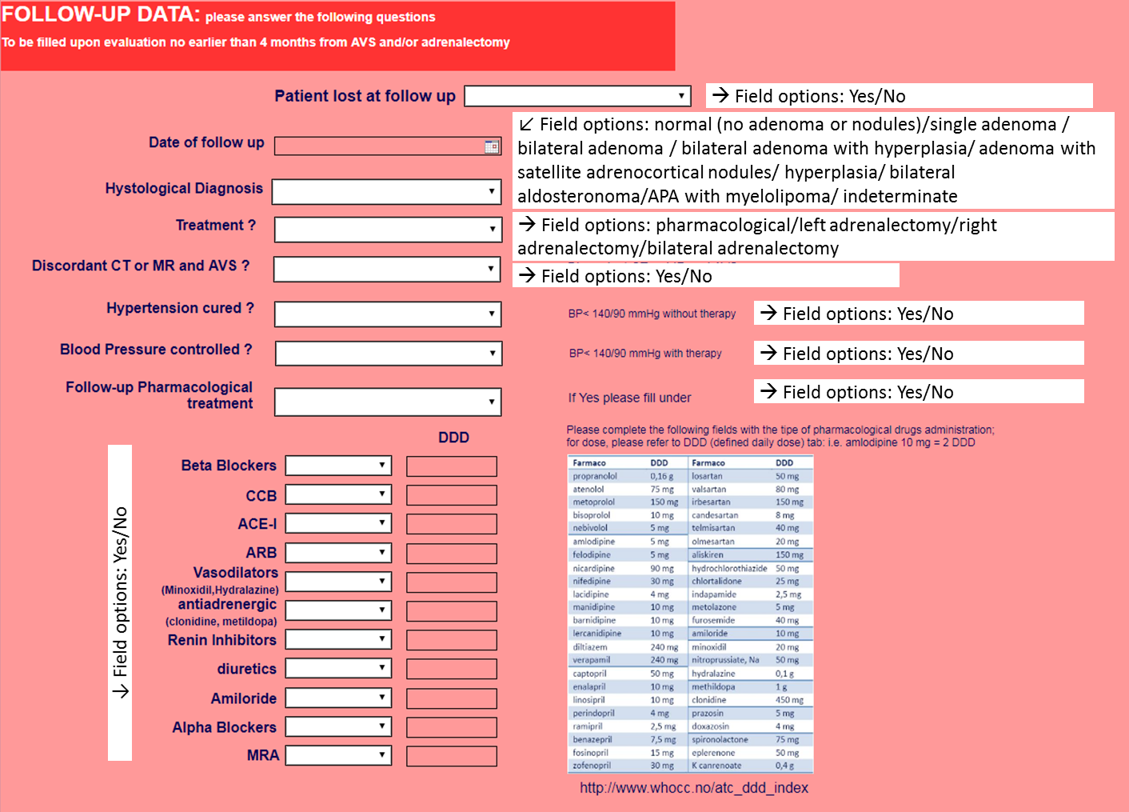
*
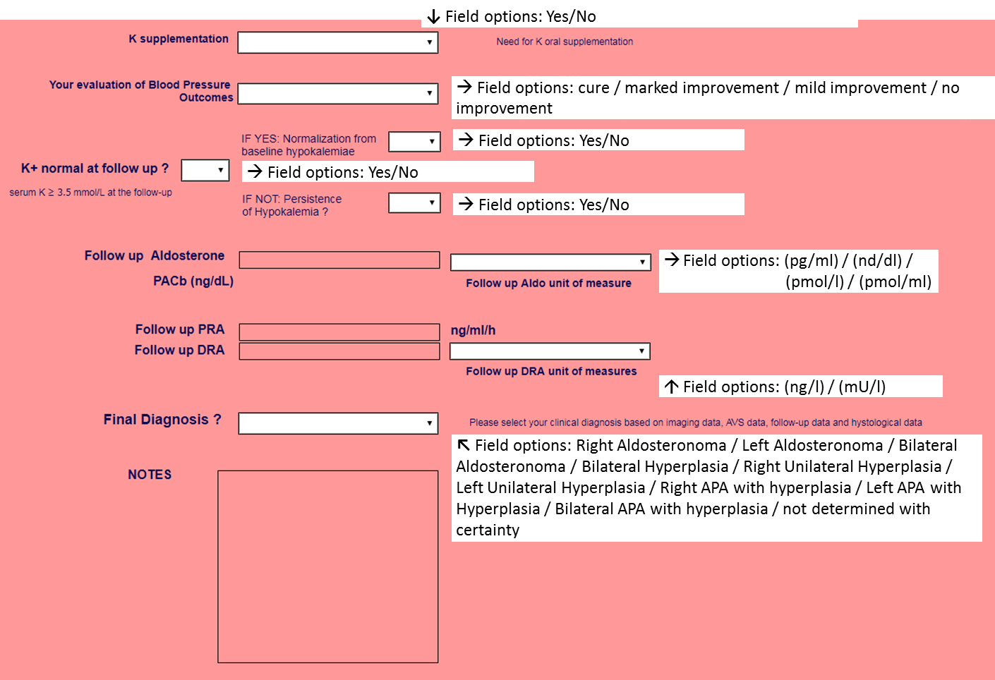
* DDD was not prespecified at the beginning of the study; was later introduced but excluded from the current analysis because not available from all centers and/or all patients
Summary List of the collected variables
- Demography (sex 1 =M 2=F, weight, BMI, race, etc.);
- AVS date (MM/DD/YYYY);
- Birth date (MM/DD/YYYY);
- Calculated age at AVS = AVS date (MM/DD/YYYY)- Birth date (MM/DD/YYYY);
- Systolic and diastolic blood pressure values at the time of AVS;
- Ongoing medical therapy at the time of AVS;
- Biochemical profile at baseline (sK⁺, plasma aldosterone concentration (PAC); plasma renin activity (PRA).
- AVS protocol (bilaterally simultaneous/sequential; stimulated/unstimulated).
- PAC and plasma cortisol concentration (PCC) in each adrenal vein and in the inferior vena cava blood;
- Concordance/discordance between imaging and AVS results.
- Treatment modality: right/left/bilateral laparoscopic adrenalectomy; medical treatment.
- Blood pressure outcome at 6-months defined as reported in Supplemental Table 2.
- Persistence /correction of hypokalaemia at follow-up.
- Serum K⁺, PAC and PRA at follow-up.
- Complications: adrenal vein rupture (appearance of persistent pain during or after catheterization, confirmed at imaging).
- Diagnosis (unilateral aldosterone-producing adenoma (APA); bilateral APA, unilateral adrenal hyperplasia; bilateral adrenal hyperplasia.
Conclusive diagnosis of unilateral PA required demonstration of biochemical cure at follow-up.

Supplemental Table 2: Pre-specified definitions of the BP outcome.

 |  | PASO CRITERIA*
Cure | normotension (BP < 140/90 mmHg) without any antihypertensive agents. | Complete clinical success
Marked improvement | normotension on the same or reduced number of medications and BP similar to baseline but with a marked decreased (> 2 drugs) of medications. | Partial clinical success
Mild improvement | a fall of systolic and/or diastolic BP > 10%, but without achievement of normotension with the same or reduced therapy.
No improvement | no fall of systolic and/or diastolic BP and/or need for increased number and/or dose of antihypertensive medications. | Absent clinical success

BP = Blood Pressure; *PASO consensus from Williams TA, Lancet Diabetes Endocrinol 2017; 5(9):689-699, for comparison

Supplemental Table 3. Number of AVS included, technique, protocol and diagnostic criteria in use at participating centers.

Center ID | n. of AVS | Years | Technique | Pharm. Stimulation | Selectivity criteria | Lateralisation criteria
#14 | 6 | 2009-2011 | Sequential | Unstimulated | SI unstim. > 3.0 | LI unstim. > 4.0
#18 | 9 | 2010-2015 | Sequential | Cosyntropin | SI cosyn > 3.0 | LI cosyn > 4.0
#2 | 11 | 2007-2009 | Bil. Simultaneous | Unstimulated | SI unstim. > 2.0 | LI unstim. > 2.0
#19 | 15 | 2012-2015 | Sequential | Unstimulated | SI unstim. > 3.0 | LI unstim. > 2.0
#4 | 17 | 2005-2012 | Sequential | Unstimulated | SI unstim. > 1.36 | LI unstim. > 3.0
#7 | 27 | 2000-2009 | Sequential | Unstimulated / Cosyntropin | SI unstim. > 2.0  SI cosyn >3.0 | LI unstim. > 4.0  LI cosyn > 4.0
#1 | 39 | 2010-2015 | Sequential | Unstimulated / Cosyntropin | SI unstim. > 2.0  SI cosyn >3.0 | LI unstim. > 3.0  LI cosyn > 4.0
#5 | 39 | 2008-2012 | Sequential | Unstimulated | SI unstim. > 2.0 | LI unstim. > 3.0
#13 | 45 | 2000-2010 | Bil. Simultaneous | Unstimulated / Cosyntropin | SI unstim. > 1.36  SI cosyn > 5.0 | LI unstim. > 2.0  LI cosyn > 2.0
#15 | 63 | 2000-2011 | Bil. Simultaneous | Unstimulated / Cosyntropin | SI cosyn > 5.0 | LI cosyn > 2.0.6
#3 | 79 | 2005-2011 | Bil. Simultaneous | Unstimulated / Cosyntropin | SI unstim. > 3.0  SI cosyn > 3.0 | LI unstim. > 3.0  LI cosyn > 3.0
#12 | 98 | 2005-2015 | Sequential | Cosyntropin | SI cosyn > 5.0 | LI cosyn > 3.0.5.0
#17 | 101 | 2004-2015 | Sequential | Cosyntropin | SI cosyn > 5.0 | LI cosyn > 4.0
#9 | 107 | 2005-2011 | Sequential | Cosyntropin | SI cosyn > 2.0 (< 2010)  SI cosyn > 3.0 (> 2010) | LI cosyn > 3.0 (< 2010)  LI cosyn > 4.0 (> 2010)
#6 | 115 | 2006-2014 | Sequential | Unstimulated / Cosyntropin | SI cosyn > 5.0 | LI cosyn > 2.0.6
#11 | 143 | 2000-2013 | Sequential | Unstimulated | SI unstim. > 2.0 | LI unstim. > 2.0
#8 | 144 | 2008-2013 | Sequential | Unstimulated | SI unstim. > 2.0 | LI unstim. > 4.0
#16 | 196 | 2000-2015 | Bil. Simultaneous | Unstimulated / Cosyntropin | SI unstim. > 2.0 | LI unstim. > 2.0
#10 | 371 | 2000-2015 | Sequential (< 2009)  Bil. Simultaneous (> 2009) | Unstimulated | SI unstim. > 2.0 | LI unstim. > 5.0

Supplemental Table 4: Baseline demographic, clinical and biochemical features of the patients
submitted to AVS-guided adrenalectomy and non-AVS-guided adrenalectomy.
Variable | AVS-guided adrenalectomy  (n = 519) | Non-AVS-guided adrenalectomy  (n = 160) | p
Age (years) | 49.5 ± 11.1 | 50.9 ± 10.5
Sex (M,%) | 61.3% | 55.6 | ns
Ethnicity (%) |  |  | ns
Caucasians | 83.7% | 88.2
Asians | 2.2% | 2.2
Africans | 0.7% | 0
Hispanics | 13.4% | 9.6
Body Mass Index (Kg/m²) | 28.4 ± 5.3 | 28.7 ± 5.2 | ns
Systolic BP (mmHg) | 154 ± 21 | 155 ± 19 | ns
Diastolic BP (mmHg) | 93 ± 13 | 94 ± 12 | ns
Heart rate (beats/min) | 72 ± 13 | 73 ± 12 | ns
Anti-hypertensive treatment (n. of drugs) | 2.31 (0-8) | 2.30 (0-8) | ns
Serum K⁺ (mmol/L) | 3.5 ± 0.5 | 3.5 ± 0.6 | ns
Hypokalemia (%, n) | 49.2%, 249/506 | 45.3%, 72/159 | ns
PRA (ng/mL/h) | 0.25 (0.20 – 0.53) | 0.31 (0.20 – 0.58) | ns
PAC (ng/dL) | 26.8 (17.5 – 43.0) | 28.2 (18.3 – 44.4) | ns
PAC (pmol/L, Système International) | 744 (486 - 1194) | 799 (508 - 1233) | ns
ARR (ng/dL)/(ng/mL/h) | 83.0 (42.5 – 151.5) | 85.6 (44.6 – 147.2) | ns
ARR (pmol/L/ng/mL/h, Système International) | 2304 (1180 - 4206) | 2376 (1238 - 4086) | ns
Imaging, Single node (%, n) | 73.2%, 349/477 | 81.1%, 120/148 | = 0.05
Single node and < 35 years old | 3.9 | 1.9 | ns
Non-bilaterally selective (by centre criteria) | - | 78.1 | -

Mean±SD, or median and IQ range (PRA, PAC and ARR) or mean and range (n. of drugs). Abbreviations: PRA: plasma renin activity;
PAC: plasma aldosterone concentration; ARR: aldosterone/renin ratio.

Supplemental Table 5: Sensitivity analysis comparing results from centers contributing with more or less than 100 AVS.
Variable | AVIS-2  (whole cohort) | Data from centers with  < 100 pts | Data from centers with  > 100 pts
Number of AVS | 1625 | 448 | 1177
Rate of bilaterally selective AVS (n, %) | 1302, 80.1% | 349, 77.9% | 953, 81.0%
Rate of lateralisation at AVS (% of all; % of bilaterally selective ) | 45.5%; 56.8% | 44.9%; 57.6% | 45.7%; 56.5%
Rate of Adrenalectomised/Medically treated/lost at follow-up patients | 41.8/40/18.2 | 36.8/40.2/23.0 | 43.7*/39.9/16.4*
AVS-guided Adrenalectomy (% of all Adrenalectomies) | 76.4 | 75.8 | 76.7
Blood Pressure outcome:
Cured/Markedly improved/Mildly improved /Not improved (%)
Adrenalectomy | 37.8/41.5/15.4/5.3 | (n = 156)  37.2/50/11.5/1.3 | (n = 487)  38.0/38.8*/16.6/6.6*
- AVS-guided | 40.0/40.0/14.4/5.5 | (n = 117)  41/48.7/8.5/1.7 | (n = 375)  39.7/37.3*/16.3*/6.7*
- Non AVS-guided | 30.5/46.4/18.5/4.6 | (n = 39)  25.6/53.8/20.5/0 | (n = 112)  32.1/43.8/17.9/6.3*
Medical therapy | 0/42.8/35/22.2 | (n = 172)  0/64.0/31.4/4.7 | (n=422)  0/34.1*/36.5/29.4*
Pharmacological treatment:
n. of drugs, mean (range)
Adrenalectomy | 1.16 (0-5) | 1.12 (0-5) | 1.17 (0-5)
Medical therapy | 2.60 (0-8) | 2.48 (0-8) | 2.65 (0-8)
Biochemical outcome:
Need for K supplementation
Adrenalectomy | 2.3 | 2.8 | 2.1
Medical therapy (on MRA) | 4.9 | 6.7 | 4.1
Biochemical failure (ARR > 30 and PRA < 1 ng/ml/h)
Adrenalectomy | 6.5 | 8.3 | 6.0
Medical therapy (on MRA) | 24.4 | 16.0 | 28.3
MRA = mineralocorticoid receptor antagonists. ARR = Aldosterone-to-Renin Ratio. PRA = plasma renin Activity. Results in bold = main end-points. * = p < 0.05 vs ‘Data from centers with less than 100 pts’.
Supplemental figure 1.

The histogram shows the valid and cumulative percentage of AVS Studies performed each year from 2000 to 2015. The publication in 2008 of the first Endocrine Society Practice Guidelines for PA in 2008 was followed by an increased number of AVS.

Supplemental figure 2.

Low rate of adrenal vein rupture causing a retroperitoneal hemorrhage in the entire cohort.

Supplemental figure 3.
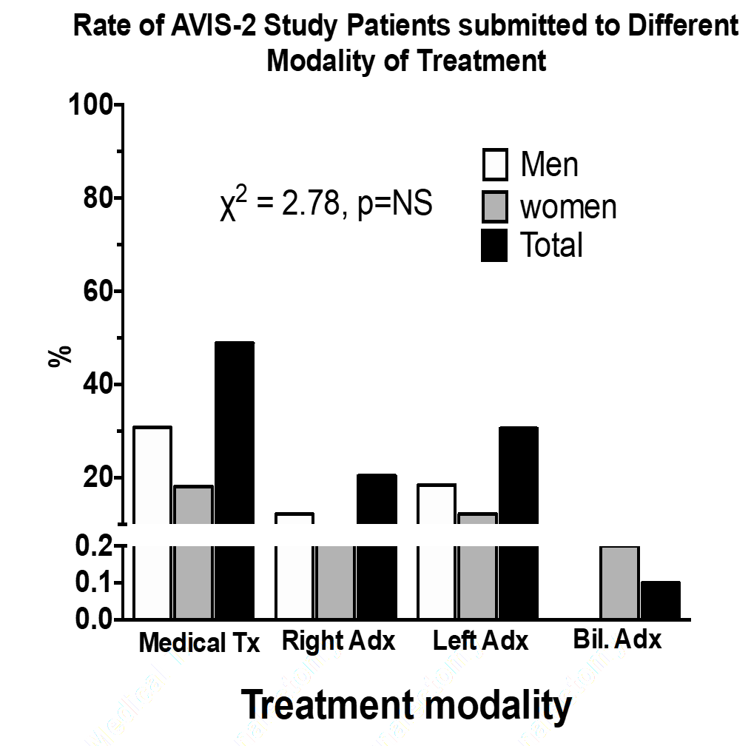

Proportion of patients in the entire AVIS-2 Study cohort of PA allocated to the different treatment modalities. Information on treatment modality was available in 1329 patients (81·8%) of the entire cohort. Adrenalectomy was performed in 678 of the patients (41·8% of the entire cohort); it involved the right side in 271 (39·9% of the adrenalectomised patients), the left side in 407 (59·9%) and in 0·1% it was done bilaterally. Medical Tx = medical therapy; Adx = adrenalectomy.

Supplemental figure 4.

Rate of patients in the entire cohort, who were lost and available, at clinical (left panel), and biochemical follow-up (right panel): the majority of the patients were not submitted to the latter for the reasons discussed in the text.

