**Subtyping of Primary Aldosteronism in the AVIS-2 Study:**

**Assessment of Selectivity and Lateralization**

**SUPPLEMENTAL MATERIAL**

Giacomo Rossittoa,z,Laurence Amarb; Michel Azizib; Anna Riesterc; Martin Reinckec; Christoph Degenhartc; Jiri Widimsky Jr.d; Mitsuhide Narusee; Jaap Deinum e; Leo Schultzekoolf; Tomaz Kocjang, Aurelio Negroh; Ermanno Rossih; Gregory Klinei; Akiyo Tanabel; Fumitoshi Satohm; Lars Christian Rumpn; Oliver Vonendn; Holger S. Willenbergo; Peter Fullerp; Jun Yang p; Nicholas Yong Nian Cheep; Steven B. Magillq; Zulfiya Shafigullinar; Marcus Quinklers; Anna Oliverast; Chin-Chen Changu; Vin Cent Wuu; Zusana Somloovad ; Giuseppe Maiolinoa, Giulio Barbierov; Michele Battistelv; Livia Lenzinia; Emilio Quaiav ; Achille Cesare Pessina,a and Gian Paolo Rossia

aUniversity of Padova, Department of Medicine-DIMED, Hypertension Unit, University Hospital, Padova, Italy;

bAP-HP, Hôpital Européen Georges Pompidou, Hypertension Unit, F-75015 Paris, France, Paris-Descartes University, Faculty of Medicine, F-75006 Paris, France, INSERM, UMR970, Paris-Cardiovascular Research Center, F-75015, Paris, France;

cMedizinische Klinik und Poliklinik IV, Klinikum der Universität München, LMU München, München;

dCharles University Prague, General Hospital, 3rd Dept. of Medicine, Prague, Czech Republic;

eNational Hospital Organization Kyoto Medical Center, Dept. of Endocrinology Clinical Research Institute, Kyoto, Japan;

fRadboud University Nijmegen, Dept. of Int. Medicine, Nijmegen, Netherlands;

gUniversity Medical Center Ljubljana

hAzienda Unità Sanitaria Locale, IRCCS Arcispedale S. Maria Nuova, Dept. of Internal Medicine, Hypertension Unit, Reggio Emilia, Italy;

iUniversity of Calgary, Foothills Medical Centre, Calgary, Canada;

lInstitute of Clinical Endocrinology, Tokyo Women's Medical University, Tokyo, Japan;

mTohoku University Hospital, Dept. of Nephrology, Endocrinology and Vascular Medicine, Sendai,

nHeinrich Heine University Düsseldorf , Nephrologie, Duesseldorf, Germany;

oDivision of Endocrinology and Metabolism, Rostock University Medical Center, Rostock, Germany;

pMonash Health, Clayton, VIC 3168 Australia;

qMedical College of Wisconsin. Endocrinology Center. North Hills Health Center, Menomonee Falls, WI 53051.;

rDept. of Endocrinology University of St. Petersburg, Russia;

sClinical Endocrinology, Charité Campus Mitte, Charité University Berlin, Berlin, Germany;

tHypertension Unit, Nephrology Dept. Hosp. del Mar Universitat Autònoma de Barcelona, Spain;

uNational Taiwan University Hospital, Dept. of Internal Medicine, Taipei, Taiwan;

vUniversity of Padova, Institute of Radiology, Padova, Italy;

z University of Glasgow, institute of Cardiovascular and Medical Sciences, Glasgow, UK

**Expanded methods; AVIS2 data collection form; Supplemental tables: 10**, **Supplemental figures:** **5**.

**Address for correspondence:**

**Prof. Gian Paolo Rossi, MD. FACC, FAHA**.

Hypertension Unit – Department of Medicine -DIMED

University Hospital via Giustiniani, 2

35126 Padova, Italy

Phone: +39-049-821.2279; Fax: +39-49-821.7873

E-mail: gianpaolo.rossi@unipd.it

**EXPANDED METHODS**

The AVIS-2 study was an observational multi-center study conceived in 2012 with the aim of creating a large database of individual adrenal vein sampling (AVS) studies performed worldwide. The original protocol was registered at clinicaltrials.gov (NCT01234220) and thereafter amended to reach the target recruitment number of 1500 patients PA patients submitted to AVS in the last 15 years (2000-2015).

**Center selection criteria**

Eligible centers were identified from those that had published in English on primary aldosteronism (PA) and/or AVS in the last decade following the PICO strategy (P, population = adults with PA; I, intervention = AVS; C, comparator = simultaneous AVS vs. sequential catheterization technique, use of cosyntropin testing vs. non-stimulated condition, use of bilaterally vs. unilaterally selective AVS results, use of absolute hormonal data vs. selectivity and lateralization indices; and O, outcome = the ways AVS was performed and interpreted, adrenal vein rupture) (24). Suitable studies were identified by computer-assisted database searches (PubMed database, U.S. National Library of Medicine) using the key words: aldosterone, primary aldosteronism (PA), endocrine hypertension, adrenal vein sampling, and the Boolean operator “AND”; scanning of reference lists; hand-searching of relevant journals; correspondence with authors of relevant reports and meeting presentations; and consultation with experts in the field.

All procedures were carried out according to the Helsinki Declaration. The protocol of the study was approved by the Ethics Committee of both the coordinating center and the participating centers.

**Inclusion/exclusion criteria**

After identification of the eligible centers the inclusion criteria were: a) age ≥ 18 years; b) center’s agreement to participate in the data collection; c) approval of the Ethics Committee. The only exclusion criteria were unwillingness of the lead investigator to participate in the study and/or lack of local Ethics Committee’s approval.

**Data collection and harmonization**

To warrant privacy protection data anonymization was systematically exploited in an *ad hoc* web-based platform ([https://fm.dmcs.unipd.it](https://fm.dmcs.unipd.it0)) and a predefined form (reported below), which was created for on-line data collection. High quality of the data was ensured by using appropriate filters to prevent input of values that were not biologically plausible and/or were in wrong unit of measures. Data were securely stored in a protected server at the coordinating center, which had full access to the dataset; each local lead investigator had access with username and password to the his/her center’s database.

**Data collection form for AVIS2 (1)**

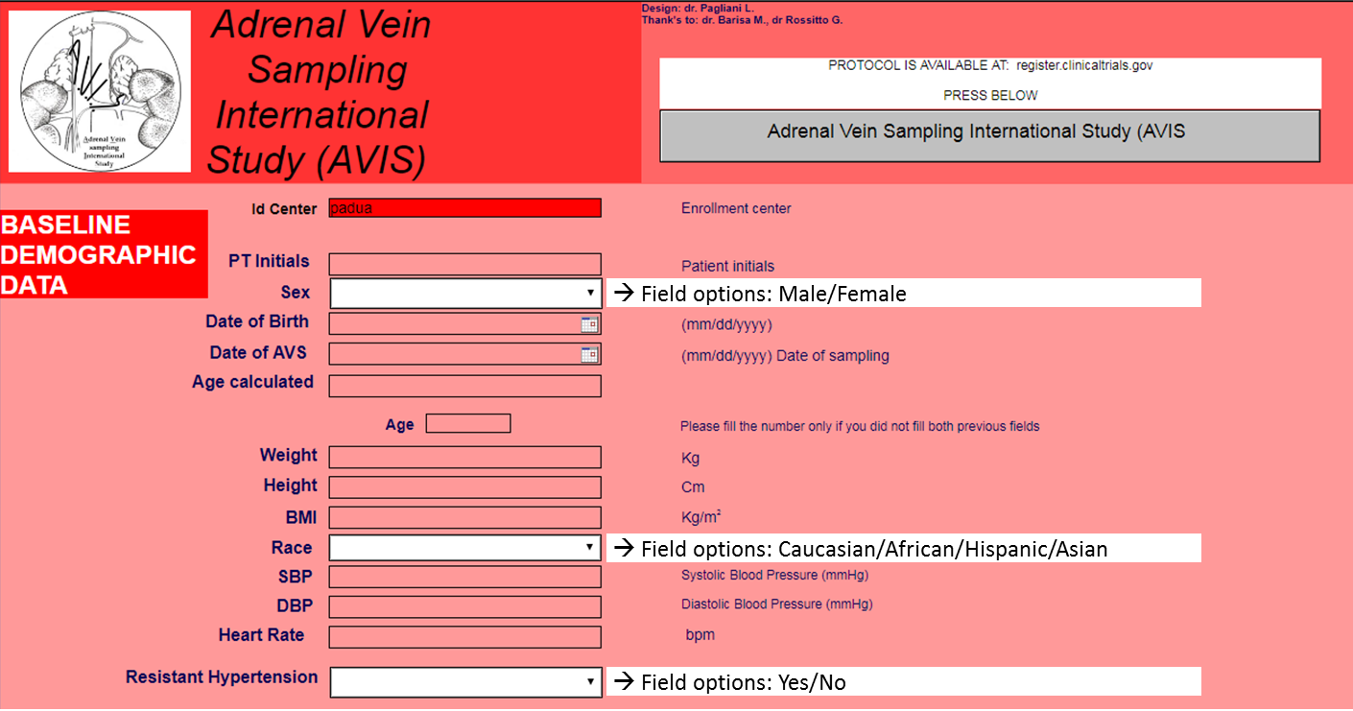

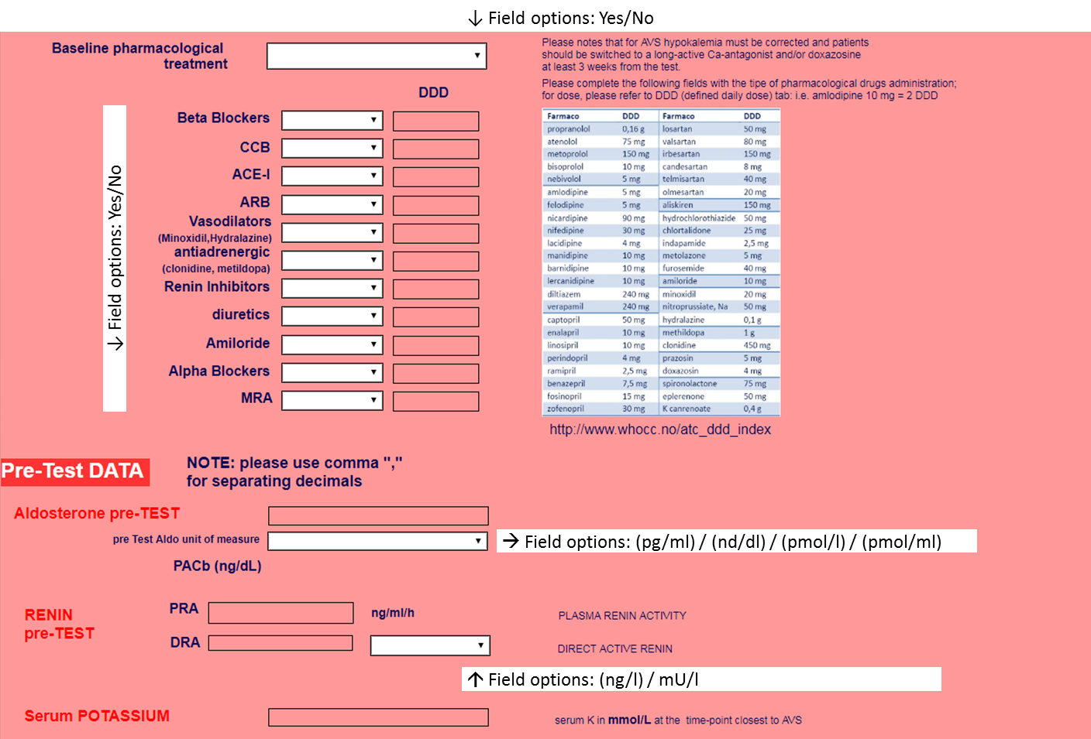

**Data collection form for AVIS2 (2)**

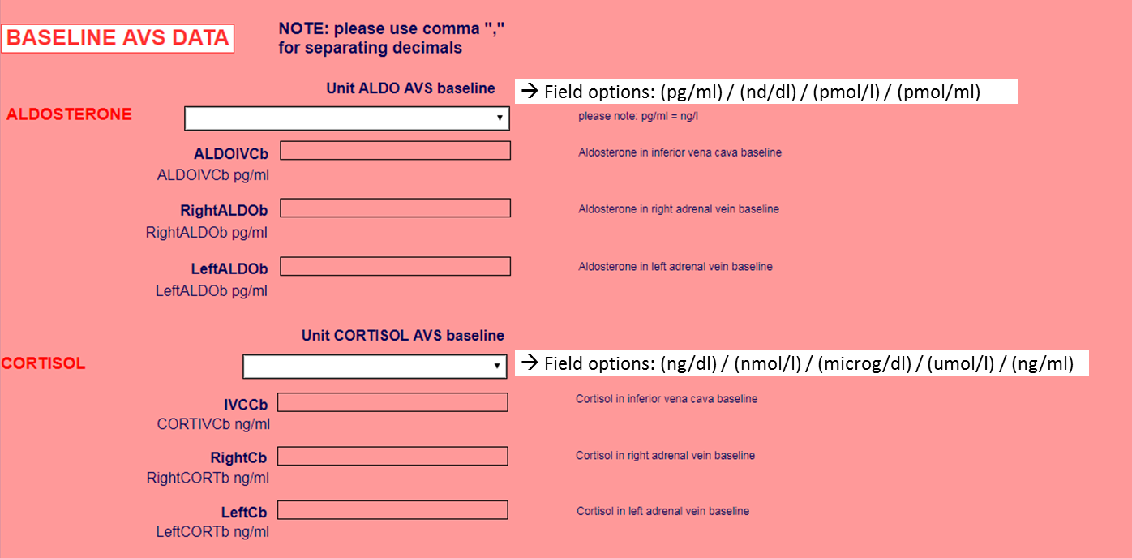

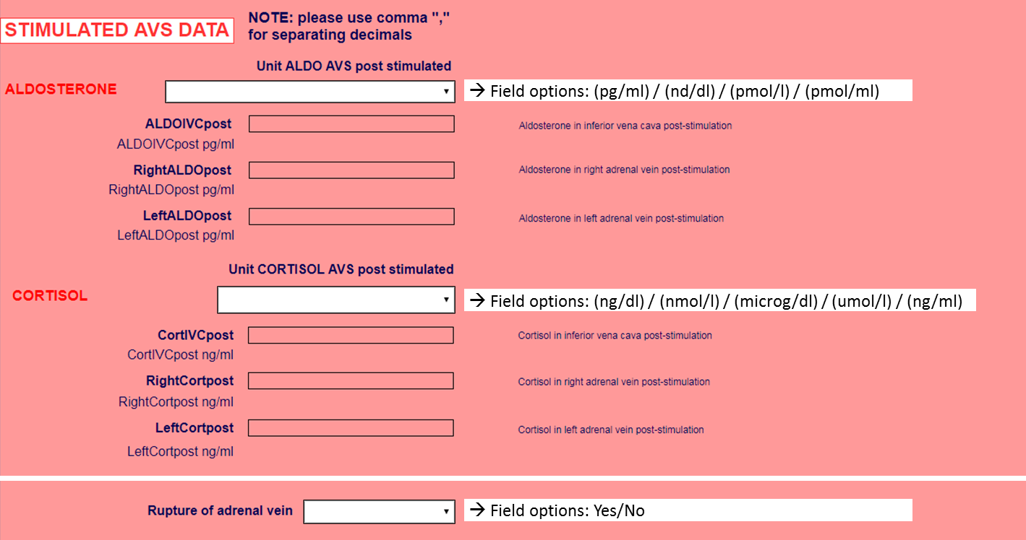

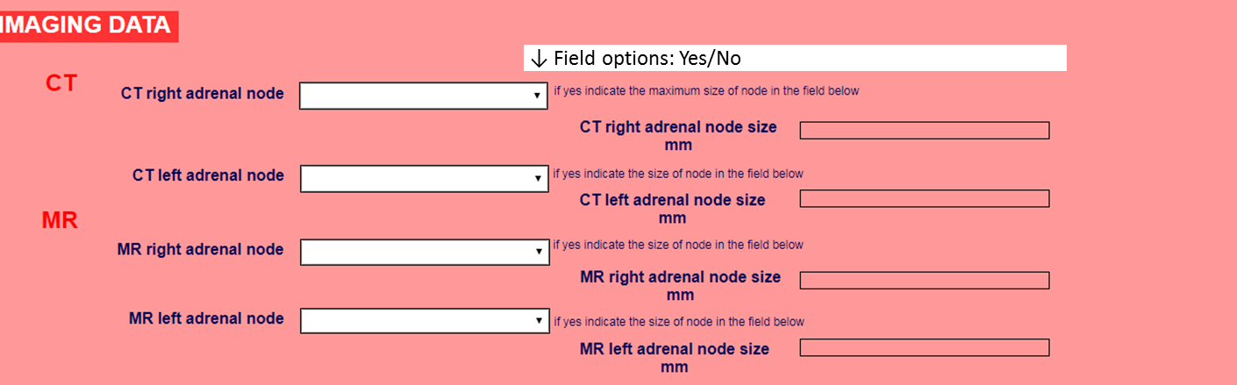

**Data collection form for AVIS2 (3)**

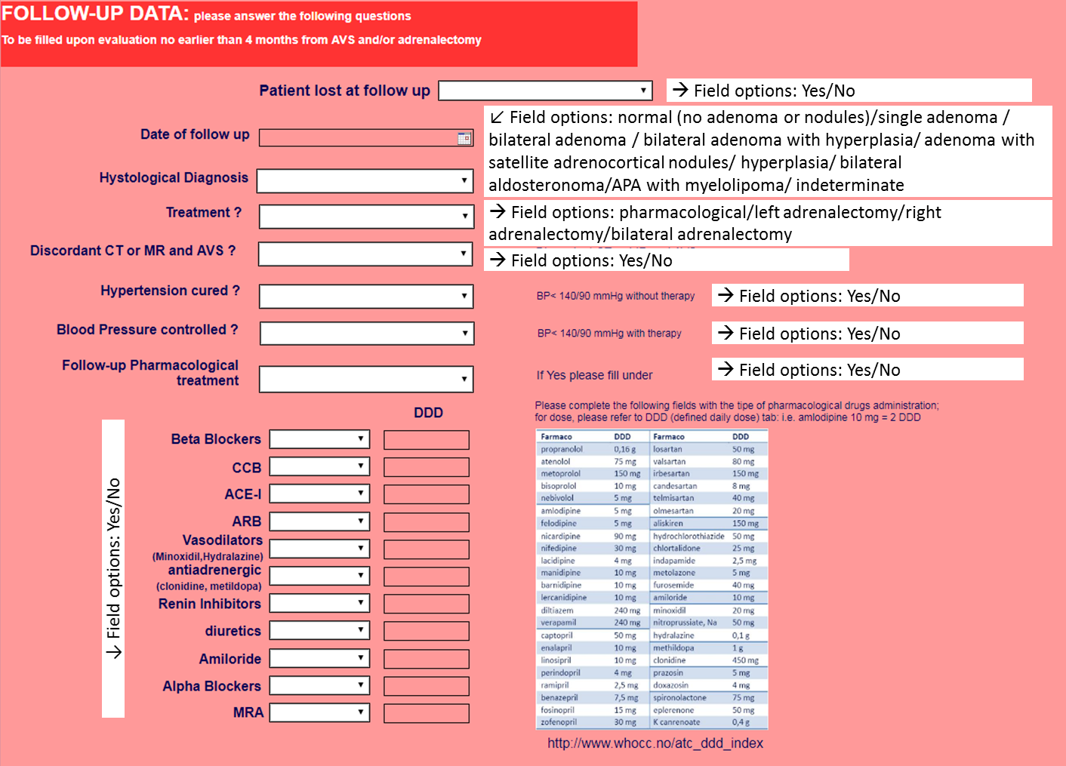

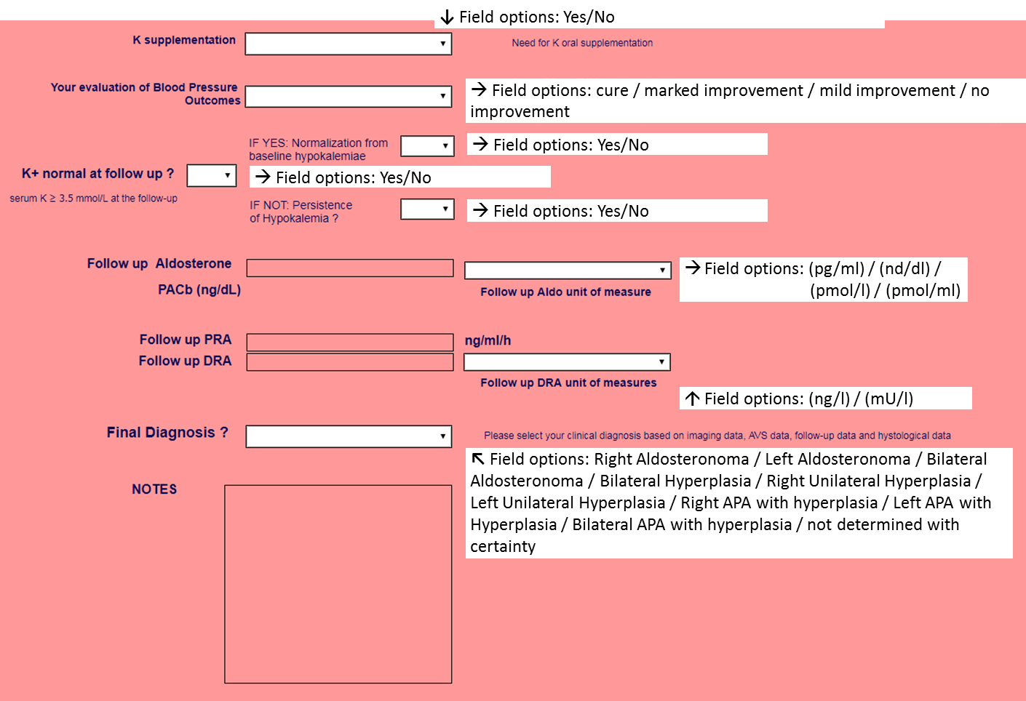

**Summary List of the collected variables**

* Demography (sex 1 =M 2=F, weight, BMI, race, etc.);
* AVS date (MM/DD/YYYY);
* Birth date (MM/DD/YYYY);
* Calculated age at AVS = AVS date (MM/DD/YYYY)- Birth date (MM/DD/YYYY) in years;
* Systolic and diastolic blood pressure values (mmHg) at the time of AVS;
* Ongoing medical therapy at the time of AVS;
* Biochemical profile at baseline (sK+, plasma aldosterone concentration (PAC); plasma renin activity (PRA).
* AVS protocol (bilaterally simultaneous/sequential; stimulated/unstimulated).
* PAC and plasma cortisol concentration (PCC) in each adrenal vein and in the inferior vena cava blood;
* Concordance/discordance between imaging and AVS results.
* Treatment modality: right/left/bilateral laparoscopic adrenalectomy; medical treatment.
* Blood pressure outcome at 6-months defined as reported in Supplemental Table 2.
* Persistence /correction of hypokalemia at follow-up.
* Serum K+, PAC and PRA at follow-up.
* Complications: adrenal vein rupture.
* Diagnosis (unilateral aldosterone-producing adenoma (APA); bilateral APA, unilateral adrenal hyperplasia; bilateral adrenal hyperplasia.

The conclusive diagnosis of unilateral PA required demonstration of biochemical cure at follow-up.

**Supplemental table 1: Pre-specified definitions of the BP outcome. The PASO criteria, which were proposed afterward based on expert consensus are also reported for comparison.**

|  |  |  |  |
| --- | --- | --- | --- |
|  |  |  | ***PASO CRITERIA\**** |
| **Cure** | | normotension (BP < 140/90 mmHg) without any antihypertensive agents. | ***Complete*** *clinical success* |
| **Improvement** | **Marked** | normotension on the same or reduced number of medications and BP similar to baseline but with a marked decrease (> 2 drugs) of medications. | ***Partial*** *clinical success* |
| **Mild** | a fall of systolic and/or diastolic BP > 10%, but without achievement of normotension with the same or reduced therapy. |
| **No improvement** | | no fall of systolic and/or diastolic BP and/or need for increased number and/or dose of antihypertensive medications. | ***Absent*** *clinical success* |

BP = Blood Pressure; *PASO consensus from *Williams TA, Lancet Diabetes Endocrinol 2017; 5(9):689-699*, for comparison

**Supplemental Table 2. Number of AVS included, technique, protocol and diagnostic criteria in use at participating centers.**

|  |  |  |  |  |  |  |
| --- | --- | --- | --- | --- | --- | --- |
| Center ID | Number of AVS | Years | Technique | Pharm. Stimulation | Selectivity criteria | Lateralisation criteria |
| #14 | 6 | 2009-2011 | Sequential | Unstimulated | SI unstim. > 3.0 | LI unstim. > 4.0 |
| #18 | 9 | 2010-2015 | Sequential | Cos. | SI Cos. > 3.0 | LI Cos. > 4.0 |
| #2 | 11 | 2007-2009 | Bil. sim. | Unstimulated | SI unstim. > 2.0 | LI unstim. > 2.0 |
| #19 | 15 | 2012-2015 | Sequential | Unstimulated | SI unstim. > 3.0 | LI unstim. > 2.0 |
| #4 | 17 | 2005-2012 | Sequential | Unstimulated | SI unstim. > 1.36 | LI unstim. > 3.0 |
| #7 | 27 | 2000-2009 | Sequential | Unstimulated / Cos. | SI unstim. > 2.0  SI Cos. >3.0 | LI unstim. > 4.0  LI Cos. > 4.0 |
| #1 | 39 | 2010-2015 | Sequential | Unstimulated / Cos. | SI unstim. > 2.0  SI Cos. >3.0 | LI unstim. > 3.0  LI Cos. > 4.0 |
| #5 | 39 | 2008-2012 | Sequential | Unstimulated | SI unstim. > 2.0 | LI unstim. > 3.0 |
| #13 | 45 | 2000-2010 | Bil. sim. | Unstimulated / Cos. | SI unstim. > 1.36  SI Cos. > 5.0 | LI unstim. > 2.0  LI Cos. > 2.0 |
| #15 | 63 | 2000-2011 | Bil. sim. | Unstimulated / Cos. | SI Cos. > 5.0 | LI Cos. > 2.0.6 |
| #3 | 79 | 2005-2011 | Bil. sim. | Unstimulated / Cos. | SI unstim. > 3.0  SI Cos. > 3.0 | LI unstim. > 3.0  LI Cos. > 3.0 |
| #12 | 98 | 2005-2015 | Sequential | Cos. | SI Cos. > 5.0 | LI Cos. > 3.0.5.0 |
| #17 | 101 | 2004-2015 | Sequential | Cos. | SI Cos. > 5.0 | LI Cos. > 4.0 |
| #9 | 107 | 2005-2011 | Sequential | Cos. | SI Cos. > 2.0 (< 2010)  SI Cos. > 3.0 (> 2010) | LI Cos. > 3.0 (< 2010)  LI Cos. > 4.0 (> 2010) |
| #6 | 115 | 2006-2014 | Sequential | Unstimulated / Cos. | SI Cos. > 5.0 | LI Cos. > 2.0.6 |
| #11 | 143 | 2000-2013 | Sequential | Unstimulated | SI unstim. > 2.0 | LI unstim. > 2.0 |
| #8 | 144 | 2008-2013 | Sequential | Unstimulated | SI unstim. > 2.0 | LI unstim. > 4.0 |
| #16 | 196 | 2000-2015 | Bil. sim. | Unstimulated / Cos. | SI unstim. > 2.0 | LI unstim. > 2.0 |
| #10 | 371 | 2000-2015 | Sequential (< 2009)  Bil. sim. (> 2009) | Unstimulated | SI unstim. > 2.0 | LI unstim. > 5.0 |

Bil. Sim. = Bilateral simultaneous AVS; Cos. = Cosyntropin; LI= lateralization index; SI= selectivity index;

**Supplemental Table 3: Baseline demographic, clinical and biochemical features of the 1625 PA patients.**

|  |  |
| --- | --- |
| Variable | Value |
| Age (years) | 50.8 ± 10.8 |
| Sex (M/F), n (%) | 985 (60.6)/ 640 (39.4) |
| Ethnicity (%) |  |
| Caucasians | 75.2 |
| Asians | 20.7 |
| Africans | 3.6 |
| Hispanics | 0.6 |
| Body Mass Index (Kg/m2) | 28.4 ± 5.3 |
| Systolic BP (mmHg) | 152 ± 20 |
| Diastolic BP (mmHg) | 92 ± 13 |
| Heart rate (beats/min) | 73 ± 12 |
| Anti-hypertensive treatment (n. of drugs) | 2.26 (0-8) |
| Serum K+ (mmol/L) | 3.6 ± 0.5 |
| Hypokalemia (%) | 41.4 |
| PRA (ng/mL/h) | 0.30 (0.20 – 0.57) |
| PAC (ng/dL) | 24.8 (15.4 – 33.6) |
| PAC (pmol/L, Système International) | 688 (428 - 933) |
| ARR (ng/dL)/(ng/mL/h) | 65.5 (36.3 – 118.8) |
| ARR (pmol/L/ng/mL/h, Système International) | 1818 (1008 - 3298) |
| Imaging (Single node/bilateral nodes/normal adrenals, %; n = 1470) | 61.5/8.4/30.1 |

Mean ± SD, or median and IQ range (PRA, PAC and ARR) or mean and range (n. of drugs). Abbreviations: PRA: plasma renin activity; PAC: plasma aldosterone concentration; ARR: aldosterone/renin ratio.

**Supplemental Table 4: Rate of selective AVS studies under unstimulated and cosyntropin-stimulated conditions**

|  |  |  |  |  |
| --- | --- | --- | --- | --- |
| SI  cut-off | **Unstimulated**  **(n=1274)** | p for comparison with the Cosyntropin-stimulated value | p for comparison with the most used post-Cosyntropin-stimulated value (SI ≥ 5.0) | **Cosyntropin**  **(n=742)** |
| **Right** | | | | |
| 1.1 | 1129 (88.6%) | ns | 2 x 10-3 | 674 (90.8%) |
| 1.4 | 1056 (82.9%)* | 4 x 10-3 | ns | 651 (87.7%)* |
| 2.0 | 951 (74.6%)* | < 10-3 | < 10-3 | 641 (86.4%)* |
| 3.0 | 779 (61.1%)* | < 10-3 | < 10-3 | 631 (85.0%)* |
| 4.0 | 692 (54.3%)* | < 10-3 | < 10-3 | 627 (84.5%) |
| 5.0 | 618 (48.5%)* | < 10-3 | < 10-3 | 621 (83.7%)* |
| **Left** | | | | |
| 1.1 | 1228 (96.4%) | 0.004 | ns | 735 (99.1%) |
| 1.4 | 1187 (93.2%)* | < 0.001 | ns | 734 (98.9%) |
| 2.0 | 1057 (83.0%)* | < 10-3 | < 10-3 | 729 (98.2%)* |
| 3.0 | 876 (68.8%)* | < 10-3 | < 10-3 | 723 (97.4%)* |
| 4.0 | 774 (60.8%)* | < 10-3 | < 10-3 | 715 (96.4%)* |
| 5.0 | 698 (54.8%)* | < 10-3 | < 10-3 | 706 (95.1%)* |
| **Bilateral** | | | | |
| 1.1 | 1099 (86.3%) | 1 x 10-2 | 3 x 10-3 | 669 (90.2%) |
| 1.4 | 1007 (79.0%)* | = 10-3 | ns | 646 (87.1%)* |
| 2.0 | 857 (67.3%)* | < 10-3 | < 10-3 | 636 (85.7%)* |
| 3.0 | 667 (52.4%)* | < 10-3 | < 10-3 | 624 (84.1%)* |
| 4.0 | 570 (44.7%)* | < 10-3 | < 10-3 | 615 (82.9%)* |
| 5.0 | 489 (38.4%)* | < 10-3 | < 10-3 | 603 (81.3%)* |

Number and rate of successful AVS studies by different selectivity index (SI) cutoffs.

Grey shaded cells identify the cutoff values recommended by current guidelines/experts’ consensus; the other values are those identified in the AVIS-1 study. The SI value cutoff of 1.4 was identified in this study by the Youden index analysis (see text for explanation and Figure 3; SIunstimulated = 1.4).

In each column * indicates that use of the higher cut-off implies a statistically significant fall of AVS studies judged to be successful at the p<0.05 alpha value, as compared to the immediately lower cutoff value.

**Supplemental Table 5: Rate of selective unstimulated AVS studies performed with or without use of the intraprocedural rapid cortisol assay (IRCA) and comparison with Cosyntropin stimulation.**

|  |  |  |  |  |  |  |
| --- | --- | --- | --- | --- | --- | --- |
| SI cutoff | **Unstimulated no IRCA**  **(n=1096)** | p for comparison with the Unstimulated IRCA | **Unstimulated IRCA**  **(n=178)** | p for comparison with the Cosyntropin-stimulated value | p for comparison with the most used post-Cosyntropin-stimulated value (SI ≥ 5.0) | **Cosyntropin-**  **stimulated**  **(C; n=742)** |
| **Right** | | | | | | |
| 1.1 | 962 (87.8%) | 0.020 | 167 (93.8%) | ns | < 10-3 | 674 (90.8%) |
| 1.4 | 896 (81.8%) | =8x10-3 | 160 (89.9%) | ns | =0.038 | 651 (87.7%)* |
| 2.0 | 798 (72.8%)* | < 10-3 | 153 (86.0%)* | ns | ns | 641 (86.4%)* |
| 3.0 | 647 (59.0%)* | < 10-3 | 132 (74.2%)* | 0.001 | =3x10-3 | 631 (85.0%)* |
| 4.0 | 576 (52.6%)* | =10-3 | 116 (65.2%)* | < 0.001 | < 10-3 | 627 (84.5%) |
| 5.0 | 516 (47.1%)* | 0.012 | 102 (57.3%)* | < 0.001 | < 10-3 | 621 (83.7%)* |
| **Left** | | | | | | |
| 1.1 | 1053 (96.1%) | ns | 175 (98.3%) | ns | ns | 735 (99.1%) |
| 1.4 | 1015 (92.6%) | =0.050 | 172 (96.6%) | 0.026 | ns | 734 (98.9%) |
| 2.0 | 893 (81.5%)* | < 10-3 | 164 (92.1%)* | < 0.001 | ns | 729 (98.2%)* |
| 3.0 | 726 (66.2%)* | < 10-3 | 150 (84.3%)* | < 0.001 | < 10-3 | 723 (97.4%)* |
| 4.0 | 639 (58.3%)* | < 10-3 | 135 (75.8%)* | < 0.001 | < 10-3 | 715 (96.4%)* |
| 5.0 | 582 (53.1%)* | =3x10-3 | 116 (65.2%)* | < 0.001 | < 10-3 | 706 (95.1%)* |
| **Bilateral** | | | | | | |
| 1.1 | 935 (85.3%) | =0.015 | 164 (92.1%) | ns | < 10-3 | 669 (90.2%) |
| 1.4 | 851 (77.6%) | 2x10-3 | 156 (87.6%) | ns | =0.047 | 646 (87.1%)* |
| 2.0 | 713 (65.1%)* | < 10-3 | 144 (80.9%)* | ns | ns | 636 (85.7%)* |
| 3.0 | 549 (50.1%)* | < 10-3 | 118 (66.3%)* | < 0.001 | < 10-3 | 624 (84.1%)* |
| 4.0 | 472 (43.1%)* | =3x10-3 | 98 (55.1%)* | < 0.001 | < 10-3 | 615 (82.9%)* |
| 5.0 | 412 (37.6%)* | ns | 77 (43.3%)* | < 0.001 | < 10-3 | 603 (81.3%)* |

Number and rate of successful AVS studies according to different selectivity index (SI) cutoff values. Cosyntropin data are shown for comparison. The grey shaded listed SI values are those recommended by current guidelines/consensus papers; the other are those identified in the AVIS-1 study. The SI value cutoff of 1.4 was identified in this study by the Youden index analysis (see text for explanation and Figure 3; SIunstimulated = 1.4).

As in Supplemental Table 5, in each column * indicates that use of the higher cut-off implies a statistically significant fall of AVS studies judged to be successful at the p<0.05 alpha value as compared to the immediately lower cutoff value.

**Supplemental Table 6: Criterion values and coordinates of the ROC curve of un-stimulated SI in the identification of Selectivity of AVS.**

|  |  |  |  |  |  |  |
| --- | --- | --- | --- | --- | --- | --- |
| **Criterion** | **Sensitivity** | **Specificity** | **+LR** | **-LR** | **+PV** | **-PV** |
| ≥0.29 | 100.0 | 0.00 | 1.00 |  | 90.5 |  |
| >0.29 | 99.86 | 0.00 | 1.00 |  | 90.5 | 0.0 |
| >0.41 | 99.86 | 1.35 | 1.01 | 0.10 | 90.6 | 50.0 |
| >0.44 | 99.72 | 2.70 | 1.02 | 0.10 | 90.7 | 50.0 |
| >0.61 | 99.72 | 12.16 | 1.14 | 0.023 | 91.5 | 81.8 |
| >0.63 | 99.43 | 12.16 | 1.13 | 0.047 | 91.5 | 69.2 |
| >0.65 | 99.43 | 13.51 | 1.15 | 0.042 | 91.6 | 71.4 |
| >0.66 | 99.29 | 13.51 | 1.15 | 0.052 | 91.6 | 66.7 |
| >0.7 | 99.15 | 14.86 | 1.16 | 0.057 | 91.7 | 64.7 |
| >0.72 | 99.01 | 14.86 | 1.16 | 0.067 | 91.7 | 61.1 |
| >0.74 | 99.01 | 17.57 | 1.20 | 0.056 | 92.0 | 65.0 |
| >0.76 | 98.87 | 17.57 | 1.20 | 0.065 | 92.0 | 61.9 |
| >0.78 | 98.87 | 18.92 | 1.22 | 0.060 | 92.1 | 63.6 |
| >0.82 | 98.30 | 18.92 | 1.21 | 0.090 | 92.0 | 53.8 |
| >0.84 | 98.30 | 24.32 | 1.30 | 0.070 | 92.5 | 60.0 |
| >0.85 | 98.16 | 25.68 | 1.32 | 0.072 | 92.6 | 59.4 |
| >0.86 | 98.02 | 25.68 | 1.32 | 0.077 | 92.6 | 57.6 |
| >0.87 | 98.02 | 27.03 | 1.34 | 0.073 | 92.8 | 58.8 |
| >0.89 | 97.73 | 27.03 | 1.34 | 0.084 | 92.7 | 55.6 |
| >0.93 | 97.45 | 28.38 | 1.36 | 0.090 | 92.8 | 53.8 |
| >0.94 | 97.31 | 28.38 | 1.36 | 0.095 | 92.8 | 52.5 |
| >1.02 | 97.31 | 43.24 | 1.71 | 0.062 | 94.2 | 62.7 |
| >1.03 | 96.88 | 44.59 | 1.75 | 0.070 | 94.3 | 60.0 |
| >1.04 | 96.88 | 45.95 | 1.79 | 0.068 | 94.5 | 60.7 |
| >1.06 | 96.74 | 45.95 | 1.79 | 0.071 | 94.5 | 59.6 |
| >1.07 | 96.46 | 47.30 | 1.83 | 0.075 | 94.6 | 58.3 |
| >1.1 | 96.46 | 52.70 | 2.04 | 0.067 | 95.1 | 60.9 |
| >1.15 | 95.75 | 52.70 | 2.02 | 0.081 | 95.1 | 56.5 |
| >1.16 | 95.47 | 54.05 | 2.08 | 0.084 | 95.2 | 55.6 |
| >1.17 | 95.47 | 56.76 | 2.21 | 0.080 | 95.5 | 56.8 |
| >1.21 | 95.04 | 56.76 | 2.20 | 0.087 | 95.4 | 54.5 |
| >1.23 | 94.76 | 58.11 | 2.26 | 0.090 | 95.6 | 53.8 |
| >1.25 | 94.76 | 59.46 | 2.34 | 0.088 | 95.7 | 54.3 |
| >1.38 | 92.21 | 59.46 | 2.27 | 0.13 | 95.6 | 44.4 |
| >1.39 | 92.21 | 60.81 | 2.35 | 0.13 | 95.7 | 45.0 |
| >1.4 | 92.07 | 62.16 | 2.43 | 0.13 | 95.9 | 45.1 |
| >1.62 | 88.39 | 62.16 | 2.34 | 0.19 | 95.7 | 35.9 |
| >1.63 | 88.39 | 63.51 | 2.42 | 0.18 | 95.9 | 36.4 |
| >1.69 | 86.83 | 63.51 | 2.38 | 0.21 | 95.8 | 33.6 |
| >1.7 | 86.69 | 64.86 | 2.47 | 0.21 | 95.9 | 33.8 |
| >1.92 | 81.16 | 64.86 | 2.31 | 0.29 | 95.7 | 26.5 |
| >1.94 | 81.16 | 66.22 | 2.40 | 0.28 | 95.8 | 26.9 |
| >2.26 | 72.66 | 66.22 | 2.15 | 0.41 | 95.4 | 20.2 |
| >2.28 | 72.52 | 67.57 | 2.24 | 0.41 | 95.5 | 20.5 |
| >2.34 | 71.67 | 67.57 | 2.21 | 0.42 | 95.5 | 20.0 |
| >2.35 | 71.67 | 68.92 | 2.31 | 0.41 | 95.7 | 20.3 |
| >2.71 | 65.72 | 68.92 | 2.11 | 0.50 | 95.3 | 17.4 |
| >2.72 | 65.58 | 70.27 | 2.21 | 0.49 | 95.5 | 17.6 |
| >2.75 | 65.01 | 70.27 | 2.19 | 0.50 | 95.4 | 17.4 |
| **Criterion** | **Sensitivity** | **Specificity** | **+LR** | **-LR** | **+PV** | **-PV** |
| >2.76 | 64.87 | 71.62 | 2.29 | 0.49 | 95.6 | 17.6 |
| >2.96 | 61.05 | 71.62 | 2.15 | 0.54 | 95.4 | 16.2 |
| >2.97 | 60.91 | 74.32 | 2.37 | 0.53 | 95.8 | 16.6 |
| >3.02 | 60.20 | 74.32 | 2.34 | 0.54 | 95.7 | 16.4 |
| >3.05 | 60.20 | 75.68 | 2.47 | 0.53 | 95.9 | 16.6 |
| >3.06 | 59.92 | 75.68 | 2.46 | 0.53 | 95.9 | 16.5 |
| >3.08 | 59.77 | 77.03 | 2.60 | 0.52 | 96.1 | 16.7 |
| >4.05 | 49.86 | 77.03 | 2.17 | 0.65 | 95.4 | 13.9 |
| >4.07 | 49.72 | 78.38 | 2.30 | 0.64 | 95.6 | 14.0 |
| >4.2 | 49.15 | 78.38 | 2.27 | 0.65 | 95.6 | 13.9 |
| >4.21 | 48.73 | 79.73 | 2.40 | 0.64 | 95.8 | 14.0 |
| >4.44 | 47.03 | 79.73 | 2.32 | 0.66 | 95.7 | 13.6 |
| >4.46 | 47.03 | 81.08 | 2.49 | 0.65 | 96.0 | 13.8 |
| >8.8 | 29.04 | 81.08 | 1.53 | 0.88 | 93.6 | 10.7 |
| >8.87 | 29.04 | 82.43 | 1.65 | 0.86 | 94.0 | 10.9 |
| >9.39 | 28.19 | 82.43 | 1.60 | 0.87 | 93.9 | 10.7 |
| >9.51 | 28.19 | 83.78 | 1.74 | 0.86 | 94.3 | 10.9 |
| >11.7 | 23.94 | 83.78 | 1.48 | 0.91 | 93.4 | 10.4 |
| >11.8 | 23.94 | 85.14 | 1.61 | 0.89 | 93.9 | 10.5 |
| >12.41 | 22.95 | 85.14 | 1.54 | 0.91 | 93.6 | 10.4 |
| >12.49 | 22.95 | 86.49 | 1.70 | 0.89 | 94.2 | 10.5 |
| >12.91 | 22.24 | 86.49 | 1.65 | 0.90 | 94.0 | 10.4 |
| >12.98 | 22.10 | 87.84 | 1.82 | 0.89 | 94.5 | 10.6 |
| >17.14 | 16.01 | 87.84 | 1.32 | 0.96 | 92.6 | 9.9 |
| >17.34 | 16.01 | 89.19 | 1.48 | 0.94 | 93.4 | 10.0 |
| >20.21 | 13.31 | 89.19 | 1.23 | 0.97 | 92.2 | 9.7 |
| >20.45 | 13.31 | 90.54 | 1.41 | 0.96 | 93.1 | 9.9 |
| >30.66 | 6.94 | 90.54 | 0.73 | 1.03 | 87.5 | 9.3 |
| >30.9 | 6.94 | 91.89 | 0.86 | 1.01 | 89.1 | 9.4 |
| >32.61 | 6.37 | 91.89 | 0.79 | 1.02 | 88.2 | 9.3 |
| >32.67 | 6.37 | 93.24 | 0.94 | 1.00 | 90.0 | 9.5 |
| >35.3 | 5.81 | 93.24 | 0.86 | 1.01 | 89.1 | 9.4 |
| >35.6 | 5.81 | 94.59 | 1.07 | 1.00 | 91.1 | 9.5 |
| >36.78 | 5.24 | 94.59 | 0.97 | 1.00 | 90.2 | 9.5 |
| >37.28 | 5.24 | 95.95 | 1.29 | 0.99 | 92.5 | 9.6 |
| >42.83 | 3.82 | 95.95 | 0.94 | 1.00 | 90.0 | 9.5 |
| >44.14 | 3.82 | 97.30 | 1.42 | 0.99 | 93.1 | 9.6 |
| >62.17 | 1.13 | 97.30 | 0.42 | 1.02 | 80.0 | 9.4 |
| >66.33 | 1.13 | 98.65 | 0.84 | 1.00 | 88.9 | 9.5 |
| >75.14 | 0.85 | 98.65 | 0.63 | 1.01 | 85.7 | 9.4 |
| >75.54 | 0.85 | 100.0 |  | 0.99 | 100 | 9.6 |
| >397.97 | 0.00 | 100.0 |  | 1.00 |  | 9.5 |

Abbreviations: +LR = positive likelihood ratio; -LR = negative likelihood ratio; +PV = positive predictive value; -PV = negative predictive value.

**Supplemental Table 7: Rates of identified unilateral PA (Lat. PA) and of unilateral adrenalectomy (Adx) in AVIS-2 by use of different combinations of cutoff values for the Selectivity Index (SI) and the Lateralization Index (LI) under unstimulated and**

**cosyntropin-stimulated conditions.**

|  |  |  |  |  |  |  |  |  |  |  |  |
| --- | --- | --- | --- | --- | --- | --- | --- | --- | --- | --- | --- |
|  | | **Unstimulated (U)**  **(n=1004)** | | | | | | **Cosyntropin (C)**  **(n=637)** | | | |
| **SI ≥ 1.4** | p value  vs 2.0 | **SI ≥ 2.0** | p value  vs 3.0 | **SI** **≥ 3.0** | p value  vs 1.4 | **SI ≥ 5.0** | p value vs  SIB ≥ 1.4  LIB ≥ 2.0 | p value vs  SIB ≥ 1.4  LIB ≥ 3.0 | p value vs  SIB ≥ 2.0  LIB ≥ 2.0 |
| **LI ≥ 2.0** | **Lat. PA** | 558 (55.6%) | < 10-3 | 475 (47.3%) | < 10-3 | 372 (37.1%) | < 10-3 | - | - | - | - |
| **Unil. Adrx** | 398  (39.6%) | < 10-3 | 335 (33.4%) | < 10-3 | 268 (26.7%) | < 10-3 | - | - | - | - |
| **LI ≥ 3.0** | **Lat. PA** | 468 (46.6%)* | < 10-3 | 400 (39.8%)* | < 10-3 | 315 (31.4%)* | < 10-3 | 269 (42.2%) | < 10-3 | ns | ns |
| **Unil. Adrx** | 366 (36.5%)* | < 10-3 | 312 (31.1%)* | < 10-3 | 248 (24.7%)* | < 10-3 | 226 (35.5%) | ns | ns | ns |
| **LI ≥ 4.0** | **Lat. PA** | 407 (40.5%)* | < 10-3 | 345 (34.4%)* | < 10-3 | 269 (26.8%)* | < 10-3 | 233 (36.6%)* | < 10-3 | < 10-3 | ns |
| **Unil. Adrx** | 340 (33.9%)* | < 10-3 | 289 (28.8%)* | < 10-3 | 229 (22.8%)* | < 10-3 | 208 (32.7%)* | 0.005 | ns | ns |
| **LI ≥ 5.0** | **Lat. PA** | 365 (36.4)* | < 10-3 | 307 (30.6%)* | < 10-3 | 242 (24.1%)* | < 10-3 | 207 (32.5%)* | < 10-3 | < 10-3 | 2 x 10-3 |
| **Unil. Adrx** | 309 (30.8%)* | < 10-3 | 260 (25.9%)* | < 10-3 | 209 (20.8%)* | < 10-3 | 186 (29.2%)* | < 10-3 | 2 x 10-3 | ns |

* = lower than previous cut-off, per column (McNemar test).

**Supplemental Table 8: Results of a sensitivity analysis performed by excluding stepwise the contribution of each of the centers that furnished pairwise unstimulated and cosyntropin-stimulated AVS results.**

The pairwise comparison of the Lateralization Index (LI) values in the sub-cohort of patients with bilaterally selective AVS on both unstimulated and post-cosyntropin conditions showed consistently lower post-cosyntropin LI values even after exclusion of each center.

|  |  |  |  |  |  |  |
| --- | --- | --- | --- | --- | --- | --- |
|  | Whole cohort | | | Unilateral PA | | |
| **Lateralization Index** | **Unstimulated** | **Post-**  **cosyntropin** | p | **Unstimulated** | **Post-**  **cosyntropin** | p |
| **Excluded center#1** | 3.81 (1.71-19.61) | 2.43 (1.40-11.45) | < 10-3 | 17.01 (3.86-32.99) | 9.96 (3.36-20.02) | 0.003 |
| **Excluded center#3** | 3.88 (1.97-21.64) | 2.38 (1.37-9.60) | < 10-3 | 21.07 (3.74-43.92) | 7.07 (3.10-19.63) | < 10-3 |
| **Excluded center#6** | 3.89 (1.60-21.08) | 2.70 (1.42-14.02) | 10-3 | 19.17 (5.33-40.02) | 10.19 (3.47-24.5) | 10-3 |
| **Excluded center#13** | 3.91 (1.98-20.60) | 2.97 (1.42-13.33) | < 10-3 | 13.98 (3.817-30.18) | 10.19 (3.15-20.55) | 3 x 10-3 |
| **Excluded center#15** | 3.79 (1.61-20.35) | 2.41 (1.37-9.59) | < 10-3 | 18.42 (3.86-33.86) | 9.96 (3.36-20.02) | < 10-3 |
| **Excluded center#16** | 3.67 (1.66-18.47) | 2.38 (1.37-9.69) | < 10-3 | 16.19 (4.27-30.18) | 9.43 (3.52-18.44) | 0.042 |

Data presented as median (interquartile range).

Successful AVS studies were defined as an SI **≥** 2.0 and **≥** 5.0 under unstimulated and post-cosyntropin conditions.

Wilcoxon test was used to assess statistical significance.

**Supplemental Table 9: Lateralization, adrenalectomy and blood pressure outcomes according to different sets of diagnostic criteria.**

|  |  |  |  |  |  |  |  |  |  |
| --- | --- | --- | --- | --- | --- | --- | --- | --- | --- |
|  | **Unstimulated**  **(n=880)** | | | | | ***Χ*2** for unstimulated  (p) | **Cosyntropin**  **(n=580)** | | ***Χ*2** for all  (p) |
| Sets of criteria | **SI ≥ 1.4**  **LI ≥ 2.0** | **SI ≥ 2.0**  **LI ≥ 2.0** | **SI ≥ 2.0**  **LI ≥ 3.0** | **SI ≥ 3.0**  **LI ≥ 2.0** | **SI ≥ 3.0**  **LI ≥ 3.0** | **SI ≥ 5.0**  **LI ≥ 3.0** | **SI ≥ 5.0**  **LI ≥ 4.0** |
| **Bilaterally selective**  (% of total) | 724 (82.3%) | 619 (70.3%) | 619 (70.3%) | 482 (54.8%) | 482 (54.8%) | < 0.001 | 478 (82.4%) | 478 (82.4%) | < 0.001 |
| **Unilateral PA** *(by AVS criteria)*  (% of total) | 508  (57.7%) | 437  (49.7%) | 369 (41.9%) | 340 (38.6%) | 289 (32.8%) | < 0.001 | 246 (42.4%) | 214 (36.9%) | < 0.001 |
| **Adrenalectomized pts** *(meeting criteria)*  (% of total)  (% of successful AVS)  (% of unilateral PA) | 367 (41.7%)  (50.7%)  (72.2%) | 311 (35.3%)  (50.2%)  (71.2%) | 289 (32.8%)  (46.7%)  (78.3%) | 246 (28.0%)  (51.0%)  (72.4%) | 227 (25.8%)  (47.1%)  (78.5%) | < 0.001  0.409  0.044* | 206 (35.5%)  (43.1%)  (83.7%) | 189 (32.6%)  (39.5%)  (88.3%) | < 0.001  < 0.001  < 0.001* |
| **Cure**  (% of total – *Figure 4 top*)  (% of adrenalectomized pts – *Figure 4 bottom*) | **156 (17.7%)**  **(42.5%)** | **135 (15.3%)**  **(43.4%)** | **125 (14.2%)**  **(43.3%)** | **104 (11.8%)**  **(42.3%)** | **95 (10.8%)**  **(41.9%)** | < 0.001  0.9957 | **84 (14.5%)**  **(40.8%)** | **75 (12.9%)**  **(39.7%)** | < 0.001  0.9854 |
| **Improvement**  (% of total – *Figure 4 top*)  (% of adrenalectomized pts – *Figure 4 bottom*) | 194 (22.0%)  (52.9%) | 160 (18.2%)  (51.4%) | 148 (16.8%)  (51.2%) | 129 (14.7%)  (52.4%) | 119 (13.5%)  (52.4%) | < 0.001  0.993 | 112 (19.3%)  (54.4%) | 106 (18.3%)  (56.1%) | < 0.001  0.955 |
| ***Marked***  (% of total)  (% of adrenalectomized pts) | 139 (15.8%)  (37.9%) | 113 (12.8%)  (36.3%) | 105 (11.9%)  (36.3%) | 93 (10.6%)  (37.8%) | 87  (9.9%)  (38.3%) | 0.002  0.981 | 95  (16.4%)  (46.1%) | 91  (15.7%)  (48.1%) | < 0.001  0.042 |
| ***Mild***  (% of total)  (% of adrenalectomized pts) | 55  (6.3%)  (15.0%) | 47  (5.3%)  (15.1%) | 43  (4.9%)  (14.9%) | 36  (4.1%)  (14.6%) | 32  (3.6%)  (14.1%) | 0.087  0.998 | 17  (2.9%)  (8.3%) | 15  (2.6%)  (7.9%) | 0.005  0.059 |
| **No Improvement**  (% of total – *Figure 4 top*)  (% of adrenalectomized pts – *Figure 4 bottom*) | 17  (1.9%)  (4.6%) | 16  (1.8%)  (5.1%) | 16  (1.8%)  (5.5%) | 13  (1.5%)  (5.3%) | 13  (1.5%)  (5.7%) | 0.917  0.979 | 10  (1.7%)  (4.9%) | 8  (1.4%)  (4.2%) | 0.971  0.992 |

Data from patients with available follow up information (n = 880/1004 for unstimulated AVS and n = 580/637 for cosyntropin-stimulated AVS). * these suggest the higher confidence of physicians in recommending adrenalectomy based on more restrictive criteria or based on cosyntropin use.

**Supplemental Table 10: Number and rate of PA patients submitted to adrenalectomy based on evidence of lateralization under unstimulated conditions, who had post-cosyntropin AVS results indicating bilateral disease.**

|  |  |  |  |  |  |
| --- | --- | --- | --- | --- | --- |
| **Diagnostic criterion** | | | | **Cosyntropin-stimulated** | |
| **SI ≥ 5.0 and LI ≥ 3.0** | **SI ≥ 5.0 and LI ≥ 4.0** |
| **Unstimulated** | **SI ≥ 1.4** | **LI ≥ 2.0** | Adrenalectomy /Lateralization (n, %) | 17/74 (23%) | 27/86 (31%) |
| **LI ≥ 3.0** | Adrenalectomy /Lateralization (n, %) | 11/43 (26%) | 20/53 (38%) |
| **LI ≥ 4.0** | Adrenalectomy /Lateralization (n, %) | - | 16/38 (42%) |
| **SI ≥ 2.0** | **LI ≥ 2.0** | Adrenalectomy /Lateralization (n, %) | 14/65 (22%) | 22/75 (29%) |
| **LI ≥ 3.0** | Adrenalectomy /Lateralization (n, %) | 11/39 (28%) | 18/47 (38%) |
| **LI ≥ 4.0** | Adrenalectomy /Lateralization (n, %) | - | 14/32 (44%) |
| **SI ≥ 3.0** | **LI ≥ 2.0** | Adrenalectomy /Lateralization (n, %) | 9/42 (21%) | 15/48 (31%) |
| **LI ≥ 3.0** | Adrenalectomy /Lateralization (n, %) | 7/25 (28%) | 12/30 (40%) |
| **LI ≥ 4.0** | Adrenalectomy /Lateralization (n, %) | - | 9/19 (47%) |

**Supplemental figure 1.**

**Rate of bilateral selectivity at different SI cutoff values on unstimulated conditions (n = 1274) and after cosyntropin- (n = 742) or metoclopramide- (n = 123) stimulation.**



**Metoclopramide**

**Cosyntropin**

**Unstimulated**

**Supplemental figure 2.**

**Frequency distribution of SI before and after cosyntropin stimulation.**

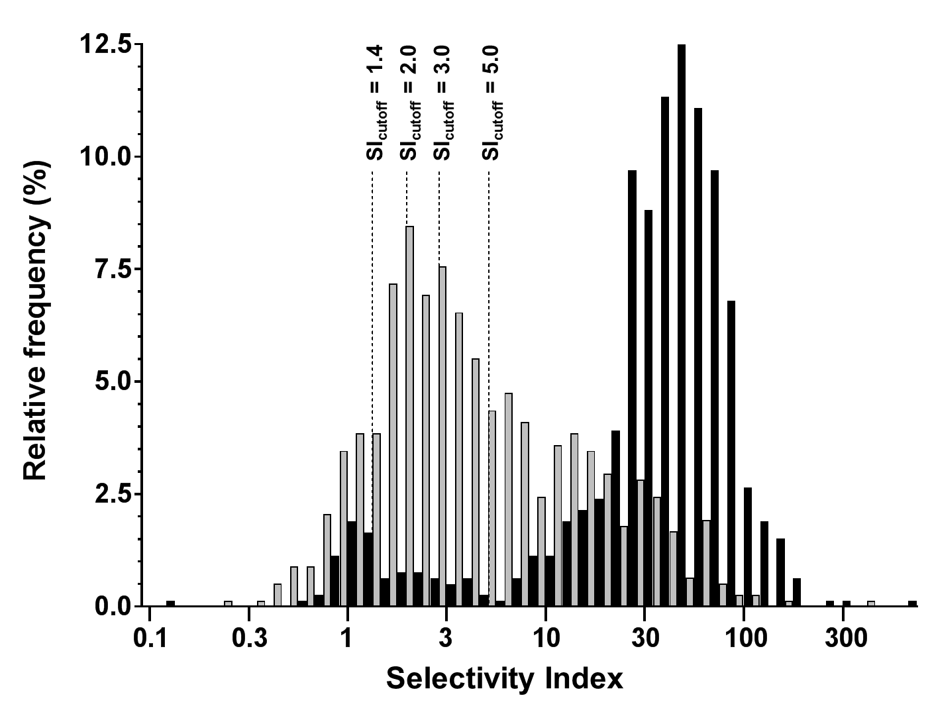

Both left and right SI values are plotted. Grey bars: Unstimulated AVS; Black bars: cosyntropin-stimulated. n = 402. X axis: Log(10) scale.

**Supplemental figure 3.**

**Rate of lateralization rate by different diagnostic values (whole cohort).**

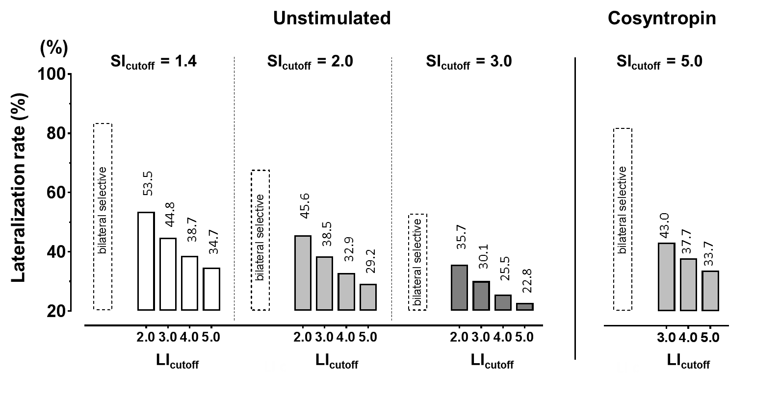

Lateralization rates in the whole cohort (regardless of availability of data on surgical indication and performance) according to protocol (Unstimulated [n= 1274] vs cosyntropin stimulated [n = 742]), SI cut-off values (1.4, 2.0 and 3.0) and LI cut-off values (2.0-5.0) are shown on top of the bars. Dashed bars = rates of bilateral selectivity, by group, for comparison with lateralization and adrenalectomy rates.

**Supplemental figure 4.**

**Impact of cosyntropin and metoclopramide stimulation on AVS diagnostic indexes.**

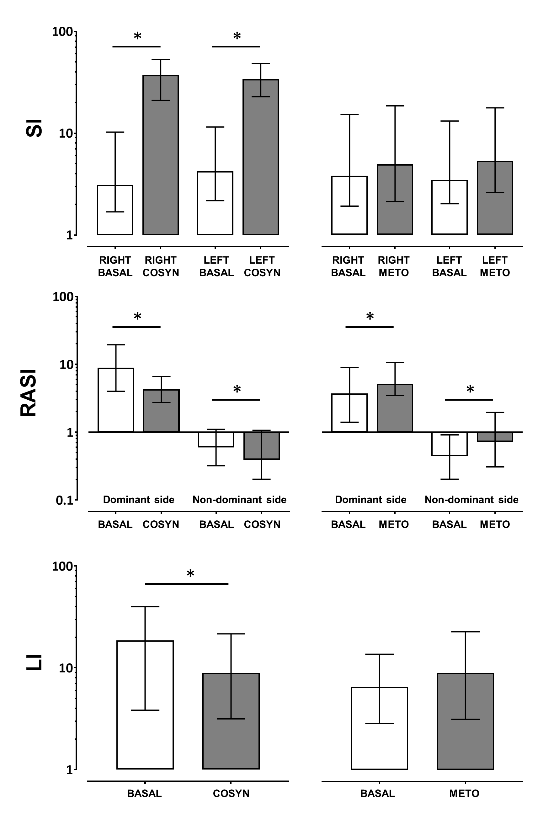

Paired analysis within subgroups of AVS performed on both unstimulated and cosyntropin- (n = 402; left panels) or metoclopramide- (n = 123; right panels) stimulated conditions. RASI and LI shown for cases with unilateral PA confirmed at follow-up. White bars = unstimulated; grey bars = stimulated. COSYN = cosyntropin, METO = metoclopramide. Median, IQR. * = p < 0.0